BASIC LINUX COMMANDS
Practical Lab Report
Student | Vivek Satpute
Training | Tutedude Cybersecurity

1. Objective
The aim of this exercise was to connect to the Linux target machine and practise two basic terminal commands: checking the current working directory and identifying the logged-in username.

2. Lab Details
Platform: TryHackMe
Room: Tutedude Cybersecurity
Room link: https://tryhackme.com/jr/tutedude-cybersec

3. Commands Performed

3.1 Display the current directory
Command: pwd
Output: /home/student
The pwd command prints the full path of the directory in which the terminal is currently working.

3.2 Identify the logged-in user
Command: whoami
Output: student
The whoami command displays the username of the account currently running the shell.

4. Screenshots
The screenshots below show the terminal commands and the corresponding answers submitted in the TryHackMe room.

4.1 Terminal output
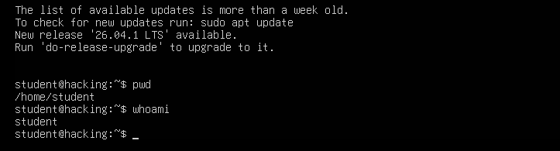
Figure 1. Terminal output showing pwd and whoami.

4.2 TryHackMe answers
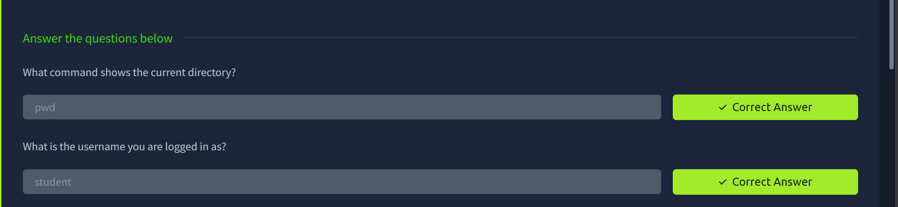
Figure 2. TryHackMe page showing both answers marked correct.

5. Result
Both commands were executed successfully. The current directory was displayed as /home/student, and the logged-in username was identified as student. Both answers were accepted by the TryHackMe room.

— Vivek Satpute

